Name Date
Class Rye Neck

Scale

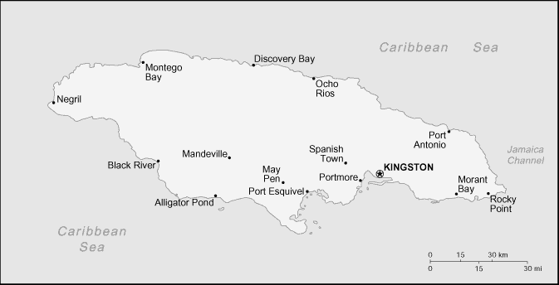

1. Define scale: ________________________________________________________

2. Use an index card to create your own moveable scale.

3. What is the distance in miles between Black River and Mandeville? _____________

4. What is the distance in miles from Alligator Pond to May Pen? ________________

5. What is the distance in miles from Montego Bay to Negril? _____________________

6. What is the distance in miles from Port Antonio to Morant Bay? _______________

7. What is the distance in miles from Rocky Point to Spanish Town? ______________

Scale Homework
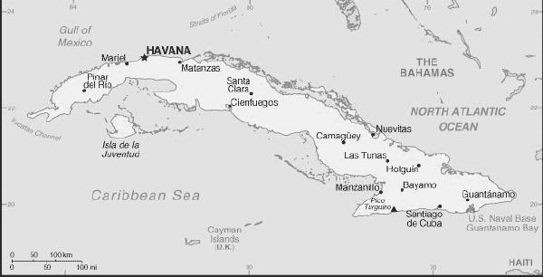

1. Define scale: ______________________________________________________

2. Use an index card to create your moveable scale.

3. What is the distance in miles from Bayamo to Guantanamo? _________________

4. What is the distance in miles from Nuevitas to Las Tunas? ___________________

5. What is the distance in miles from Pinar del Rio to Havana? ____________________

6. What is the distance in miles from Santa Clara to Matanzas? _________________

