Name Date
Class Rye Neck

Sumer/Mesopotamia Study Guide

1. Mesopotamia has two other names. List them:
- ________________________
- ________________________

2. Why would a civilization settle next to water?
__________________________________________________________________

3. List the ways the Sumerians solved the problem they were facing in controlling their water source.
- ____________________________
- ____________________________
- ____________________________

4. True or False. Surplus food led to division of labor in Sumer. If false, explain why:
______________________________________________________________________

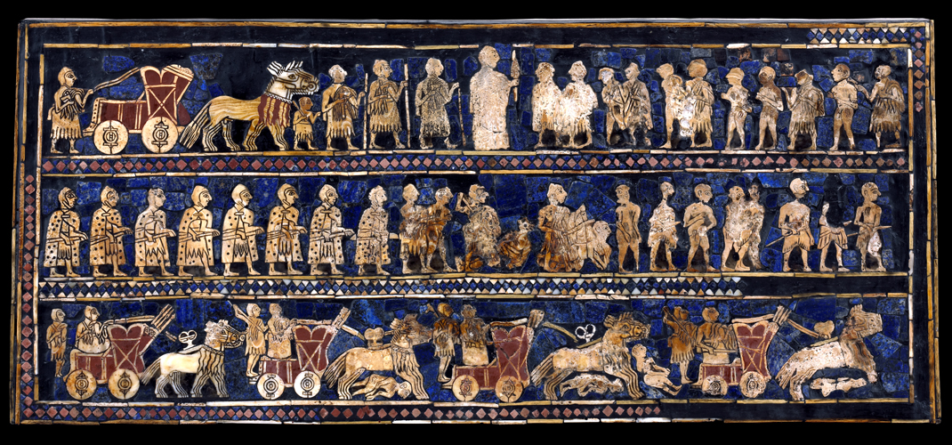

5. Which civilization made this art piece known as the Standard of Ur? ___________________

6. True or False. The standard of Ur shown above focuses on farming. If wrong write what it does focus on. ________________________________________

7. Which characteristic of civilization is being shown in the Standard of Ur? Explain how you know. ____________________________________________________________________________________________________________________________________________________________

8. Why did the Sumerians build ziggurats? ___________________________________________

9. What invention made life easier for the Sumerians?
- Ziggurat B. wheel C. gold dagger D. pictographs

10. True or False. The first empire was the Akkadians and was ruled by Sargon. If false, explain why. ________________________________________________________________________

11. What civilization is known for its Code of Laws?
- Sumer B. Babylonians C. Neo-Babylonians D. Phoenicians

12. Why are the Code of Laws so important? ______________________________________________________________________________

13. Which characteristic does the Code of Laws fit into? Explain your answer.
____________________________________________________________________________________________________________________________________________________________

14. -Siege Warfare
-Battering Rams
-Moveable towers
- Use of fear
The bulleted list above was used by the Assyrians for what purpose?
- Peace B. military strategies C. keep slaves in check D. please the gods

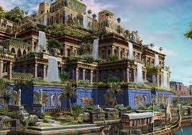
15. This wonder of the world is best known for the Neo-Babylonians. What is it?
_________________________________________________________________________

16. This wonder of the world shows that the Neo-Babylonians most cared about what?
- Beauty B. plants C. water D. war

17. Which characteristic of a civilization is being shown above? Explain your answer.
____________________________________________________________________________________________________________________________________________________________

18. True or False. The Phoenicians are best known for their alphabet.

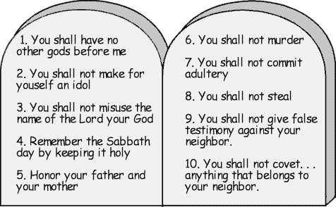
19. True or False. This picture is showing you Hammurabi’s Code of Laws. If false, explain why.
_____________________________________________________________________________

20. What civilization is known for ten written rules shown above? _________________________

21. What characteristic of a civilization is being shown above? Explain your answer.
____________________________________________________________________________________________________________________________________________________________

22. During which era did humans first practiced stable food supply? ________________________

23. Explain how you find the distance between two cities on a map:
____________________________________________________________________________________________________________________________________________________________

24. Complete the graphic organizer below.

Empire | Ruler | Achievements | Rank  (List them by most important 1-4)  *Opinion* | Explain your rank.
Akkadians

Assyrians

Babylonians

Neo-Babylonians

