Name:____________________________________ Date: _________________

Ancient India DBQ

Theme: Ancient Indian religions.

Directions: The following tasks are based on the accompanying documents (1-4). The documents may have been edited for the purpose of this exercise. The task is designed to test your ability to work with historical documents. As you analyze the documents, take into account both the source of the document and the author’s point of view.

Historical Context: When Ancient India was developing there were two main religions that the people of this civilization practiced. These two religions are Hinduism and Buddhism. Each one became a prominent part of the Indian culture and had a great influence on the people of this country.

Part A- Short Answer
The following documents show how Hinduism and Buddhism have influenced India. Examine each document carefully, and then answer the question(s) which follow.

Part B- Essay
Task: Which religion, Hinduism or Buddhism, has had a greater influence on the culture and people of Ancient India?
- You must use at least 2 documents.
- You must bring in outside information.
- You must prove how the religion you are choosing has affected the Indian civilization.

Part A:

Document #1
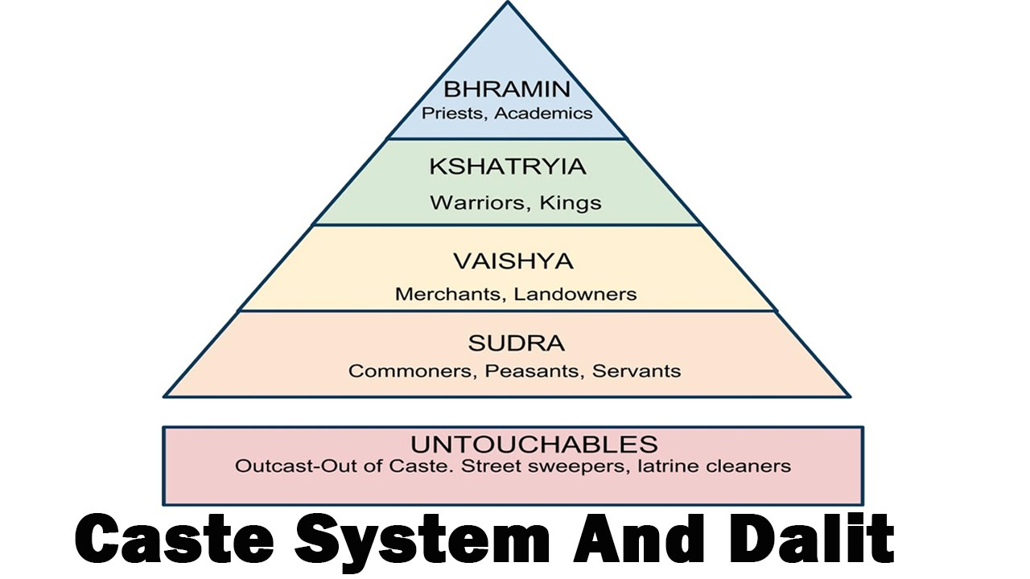

1. Why are the Brahmins at the top of the caste system?
_____________________________________________________________________
_____________________________________________________________________

2. Why are the untouchables not attached to the social pyramid?
____________________________________________________________________________________________________________________________________________

3. Which religion is the caste system from?
- Buddhism C. Hinduism
- Judaism D. Christianity

Document #2:
Hindu Beliefs Chart
Dharma: the rules everyone must follow

Karma: cause and effect of one's actions

Reincarnation: the rebirth of a person's soul after death into a higher or lower caste

1. How does dharma and karma affect someone’s reincarnation?
___________________________________________________________________________________________________________________________________________________________________________________________________________________________

Document #3:

4 Noble Truths
1 | Suffering and unhappiness are a part of human life. No one can escape sorrow.
2 | Suffering comes from our desires for pleasure and material goods. People cause their own misery because they want things they cannot have.
3 | People can overcome desire and ignorance and reach nirvana (a state of perfect peace). Reaching nirvana frees the soul from suffering and from the need for further reincarnation.
4 | People can overcome ignorance and desire by following an eight fold path that leads to wisdom, enlightenment, and salvation.

1. How does someone reach nirvana? ____________________________________________________________________________________________________________________________________________

2. What religion promotes the Four Noble Truths?
- Hinduism B. Judaism C. Buddhism D. Christianity
Document #4:

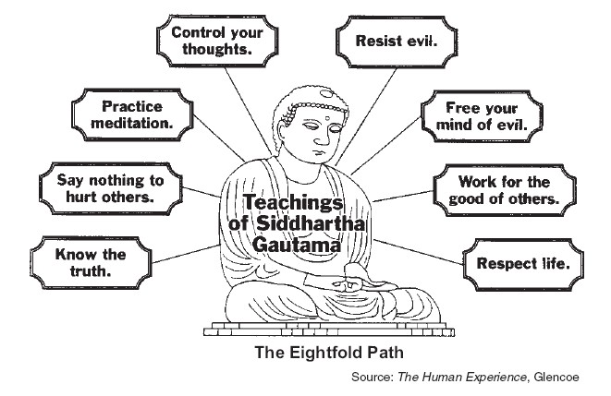

1. When following The Eightfold Path what are you trying to achieve?
- Nirvana B. peace C. god D. enlightenment

2. How are documents 3 and 4 similar?
__________________________________________________________________________________________________________________________________________________________________________________________________________________

Part B- Essay
Task: Which religion, Hinduism or Buddhism, has influenced Ancient India more?
- You must use at least 2 documents.
- You must bring in outside information.
- You must prove how the religion you chose influenced India but citing specific examples from the documents as well as outside information.

Area | Description | Points worth | Total  Points | Points Given
Documents | Answer the questions to documents 1-4 correctly | 2 points each | 16 points total
Annotations/Notes | Notes around document reflect thought and analysis. | 1 Point each document | 4 points total
Introduction/Conclusion | Having a clear introduction and conclusion in essay | 2 points introduction  2 points  conclusion | 4 points total
Topic Sentences | Topic sentence clearly introduces each paragraph | 2 points for topic sentence of body paragraph | 5 points total
Grammar | Correct use of grammar | 2 points | 5 points total
Organization | There is a clear sense of organization throughout the essay | 5 points | 5 points total
Task | Essay addresses the task | 16 points | 16 points total
Documents | Cites 2 documents | 10 points each | 20 points total
Analysis | Analyzes 2 documents | 10 points each | 20 points total
Outside Information | Brings in outside information as evidence. | 5 points total | 5 points total

Grade: _____________________________

Comments: _________________________________________________________________________________________

