Historical Context: During the 17th and 18th centuries, most major European nations believed that colonization was an important step in gaining wealth and building empires. (Background information)

Task: How did the 13 Colonies support England in their quest to build an empire? (Essay question)

Topic/Theme/Time: Other important/relevant information:

I. Introduction: G.S./Historical Context
S.S./Definition
T.S./Argument
II. Body paragraph:
-Doc 1
-Doc 2
III. Conclusion:

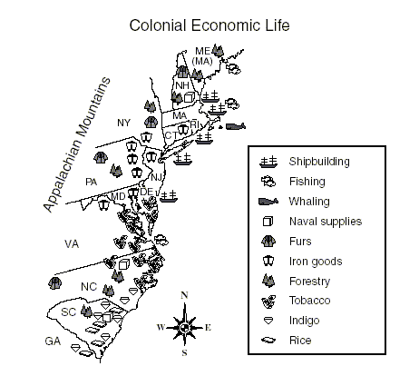

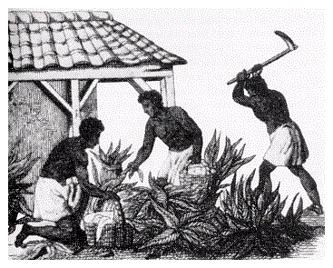 Africans were the immigrants to the British New World that had no choice in their destinations or destinies. Despite the complete lack of a slave tradition in mother England, slavery gradually replaced indentured servitude as the chief means for plantation labor in the South. No northern or middle colony was without its slaves. From Puritan Massachusetts to Quaker Pennsylvania, Africans lived in bondage. Economics and geography did not promote the need for slave importation like the plantation South. Consequently, the slave population remained small compared to their southern neighbors. As British colonists became convinced that Africans best served their demand for labor, importation increased. By the turn of the eighteenth century African slaves numbered in the tens of thousands in the British colonies.

Taken from The Growth of Slavery, www.ushistory.org.

