Name: ______________________________ Date: ________________
Geography Notes:
I. Geography: The study of the __________________, including ________________, ___________________ and how they affect the people who live there.
- Two main questions geographers try to answer:
- ______________________________________________________
- ______________________________________________________
*To help answer these questions, they use the:_________________________________.
II. 5 Themes:
- ____________ – Geographers begin to study a place by finding where it is, or its location.
Example: ______________________________________________________
- _____________ – Geographers study the physical and human features of a location.
Example: ______________________________________________________
- _______________________________ – Geographers study how people affect or shape physical characteristics of their natural surroundings and how their surroundings (environment) affect the people.
Example: ______________________________________________________
- ____________________ – Helps explain how people, goods, and ideas get from one place to another.
Example: ______________________________________________________
- ____________________ – Geographers compare the climate, land, population, or history of one place to another. They group similar areas together.
Example: ______________________________________________________
III. Geographer’s Tools:
- The two main tools used by a geographer would be ____________________ and __________________.
- The most accurate portrayal of the earth would be a ______________________. Maps try to show the earth on a _________________ surface which causes ________________________.
IV: Types of Maps:
- There are different types of maps depending on what they show.
- A ____________________________ map shows borders and capitals.
- A _____________________ map shows landforms and elevation.
*(See pages R2-R13 for examples of political and physical maps.)
V: The Parts of a Map:
- Compass Rose: A compass rose tells the cardinal directions, which are _____________________________________________.
Fill in the compass rose:
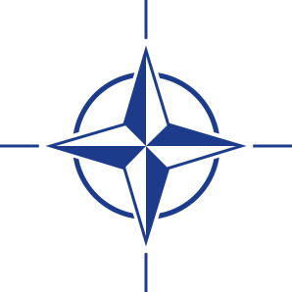
- Scale: The scale on a map tells you the relative ________________ on the map to the real world. For example:, a map’s scale may tell you that one inch on the map equals one mile in the real world. (See Scale Worksheet)
- Key: The key, or legend, on a map explains what ________________________. For example: The symbolmeans that a city is the __________________.
- Grids: Many maps use a grid of parallels and meridians. These ___________________ and ___________________ lines help to determine ______________ location or your global ___________________.
VI. Longitude and Latitude:
- Latitude lines:
  - run _____________ to ________________. (“Lat is ____________”)
  - Are also called _________________ because they never touch each other.
  - Used to measure distances ________________ and ________________ of the EQUATOR.
  - The ________________ is 0◦ (degrees) latitude.
  - The Tropic of _______________ and the Tropic of _____________________ are two special ______________ lines that are 23 ½ ◦ north and south of the equator.

- LONGitude lines:
  - run __________________ to _____________________. (LONG)
  - Are also called ____________________ of longitude.
  - Used to measure distances _________________ and _______________ of the PRIME MERIDIAN.
  - The _____________ _________________ is 0◦ (degrees) longitude.
  - All lines of longitude meet at the _______________ and ______________ Poles.

**If you’re given coordinates to find a location on a map just use your _____________! Place on finger on the _____________ line and one on the ______________ line. Then bring your fingers together slowly until they meet.

Latitude and Longitude Practice:
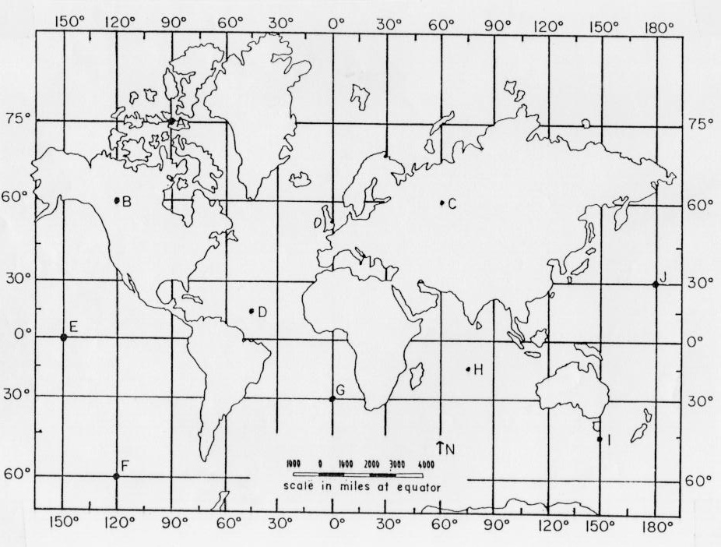

A: ___________ B: _____________ C: ______________
D: ___________ E: _____________ F: ______________
G: ___________ H: _____________ I: _______________
J: ____________

