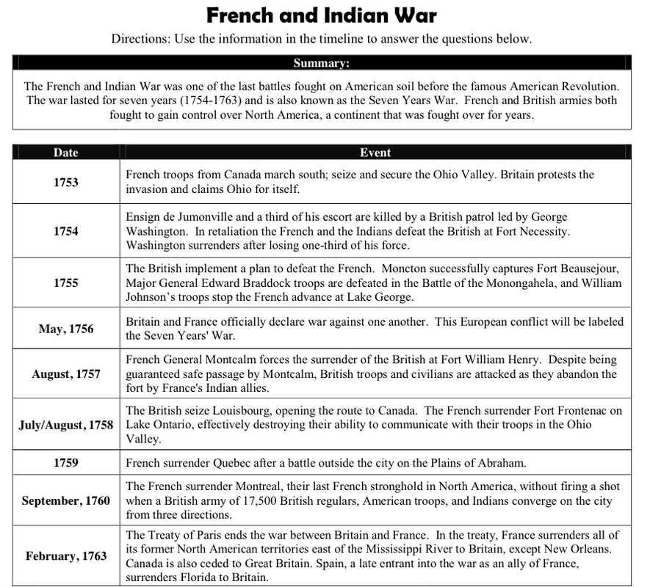

1. What two European countries declared this war?

2. What is another name for the French and Indian War?

3. What treaty was signed to end the war?

4. Which British general later became President?

5. Where was the last French stronghold in North America that was surrendered in 1760?