Name Date
Class Rye Neck

Early Humans Study Guide

1. Complete the following chart for the four social scientists

Social Scientist | Definition
anthropologist | Someone who studies how people develop into culture groups.
archaeologist | Someone who studies how early people lived through artifacts and fossils left behind.
historian | Studies history through written documents
geographer | Someone who studies earth’s landforms and climate

2. What were Lucy’s two abilities?
- Crawl on all fours and use her hands
- Biped and made fire
- Biped and had opposable thumbs
- Could communicate and make fire

3. True or False. Homo sapiens or wise man could communicate. These hominids are most closely similar to us today. TRUE

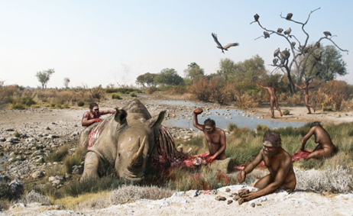
4. Name the hominid being shown in the picture above? __Homo Habilis (handyman)___

5. Explain why hominids created cave art: To express themselves and show how they lived and what was important to them.
6. The New Stone Age or the Neolithic Era began with a warming trend which led plants to grow and then humans to learn how to grow crops.

7. Describe life for a hunter and gatherer: Life for a hunter gatherer was not easy. They would have to move around following animals, setting up temporary shelters until the food source ran out.

8. True or False. Humans during the Stone Age created tools out of metal. False-mostly stone.

9. Put the following creations during the Stone Age in correct order. Then explain what each one is.

Stable food supply Permanent shelters Complex Jobs
Domestication Creation of villages
Creation Explanation
- Stable food supply: Humans begin to farm and have a constant source of food.
- Domestication : Humans begin to tame and control animals which met their needs.
- Permanent Shelters: Because humans had a constant food source, they could stay in one spot.
- Creation of villages: Humans will form societies with other humans where they live in a community or village.
- Complex jobs (social divisions): Humans divide up the work in a village and specialize in specific jobs.

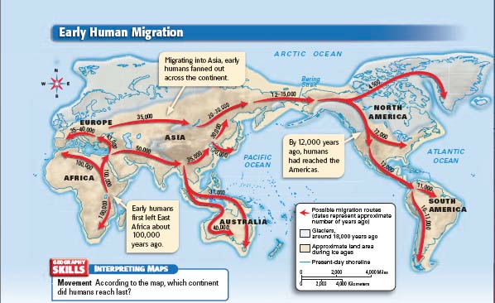
10. On what continent did the earliest human start? Africa
11. How did humans cross from Asia to North America? Scientists believe the first Americans crossed the Beringia land bridge which was exposed during the Ice Age.
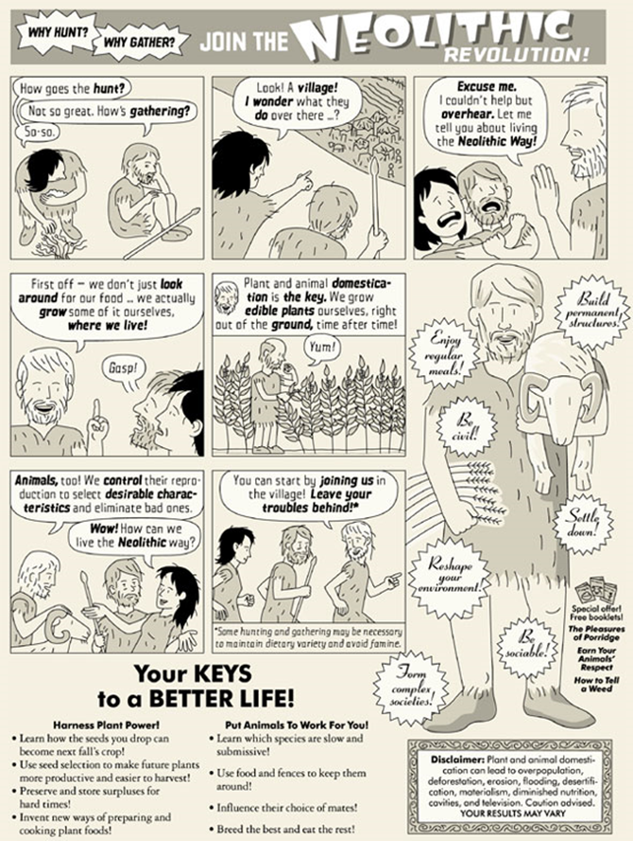
12. The first box represents what time period? Paleolithic Era
13. Name all the ways the cartoon shows how life improved during the Neolithic Revolution:
- Constant source of food
- Specialize in jobs
- Live in a village with other people
- Store surplus food
- Invent new ways of preparing food

14. Define prehistory: A period of time before humans created written language.

15. Which continent do you think would be the last one to be settled by human beings?
D. North America

16. Describe the difference between hunters and gatherers and an agricultural society:

Hunters and Gatherers | Agricultural Society
Hunters and gathers were nomads who did not have a constant source of food. (AKA farming!) | These people stayed in one spot because they could farm and raise animals, which gave them a surplus of food.

17. Explain how you use longitude and latitude: Use the x and y axis of a map to locate the coordinates or use the coordinates to find the exact location of some place on earth.

18. Explain how you find direction using a compass: The compass shows cardinal and/or intermediate directions which help you located places on a map.

19. Draw a compass rose:

