Name Date
Class Rye Neck

Early Humans Study Guide

1. Complete the following chart for the four social scientists

Social Scientist | Definition
anthropologist
archaeologist
 | Studies history
geographer

2. What were Lucy’s two abilities?
- Crawl on all fours and use her hands
- Biped and made fire
- Biped and had opposable thumbs
- Could communicate and make fire

3. True or False. Homo sapiens or wise man could communicate. These hominids are most closely similar to us today.

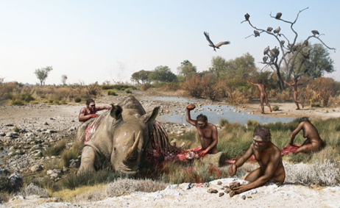
4. Name the hominid being shown in the picture above? ____________________________

5. Explain why hominids created cave art: _________________________________________
_________________________________________________________________________
6. The New Stone Age or the __________________________________ began with the creation of a ______________________________________.

7. Describe life for a hunter and gatherer: ______________________________________________
_____________________________________________________________________________

8. True or False. Humans during the Stone Age created tools out of metal.

9. Put the following creations during the Stone Age in correct order. Then explain what each one is.

Stable food supply Permanent shelters Complex Jobs
Domestication Creation of villages
Creation Explanation
- ____________________________: ___________________________________________
- ____________________________: ___________________________________________
- ____________________________: ___________________________________________
- ____________________________: ___________________________________________
- ____________________________: ___________________________________________

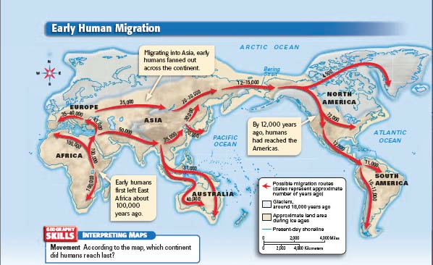
10. On what continent did the earliest human start? _________________________
11. How did humans cross from Asia to North America? __________________________________
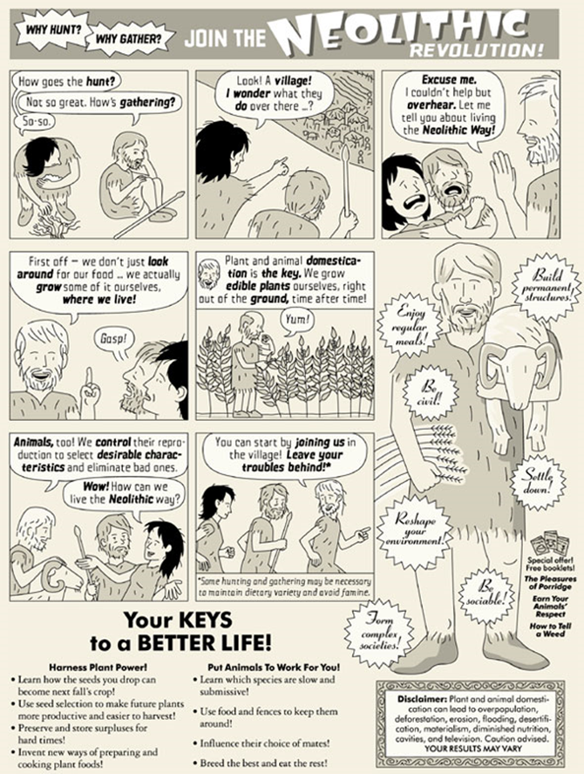
12. The first box represents what time period? ______________________________
13. Name all the ways the cartoon shows how life improved during the Neolithic Revolution:
- ______________________________________
- ______________________________________
- ______________________________________
- ______________________________________
- ______________________________________

14. Define prehistory: ____________________________________________________

15. Which continent do you think would be the last one to be settled by human beings? ______________________________________

16. Describe the difference between hunters and gatherers and an agricultural society:

Hunters and Gatherers | Agricultural Society

17. Explain how you use longitude and latitude: ______________________________________________________________________________

18. Explain how you find direction using a compass: ______________________________________

19. Draw a compass rose:

