Chapter 2 Vocabulary Review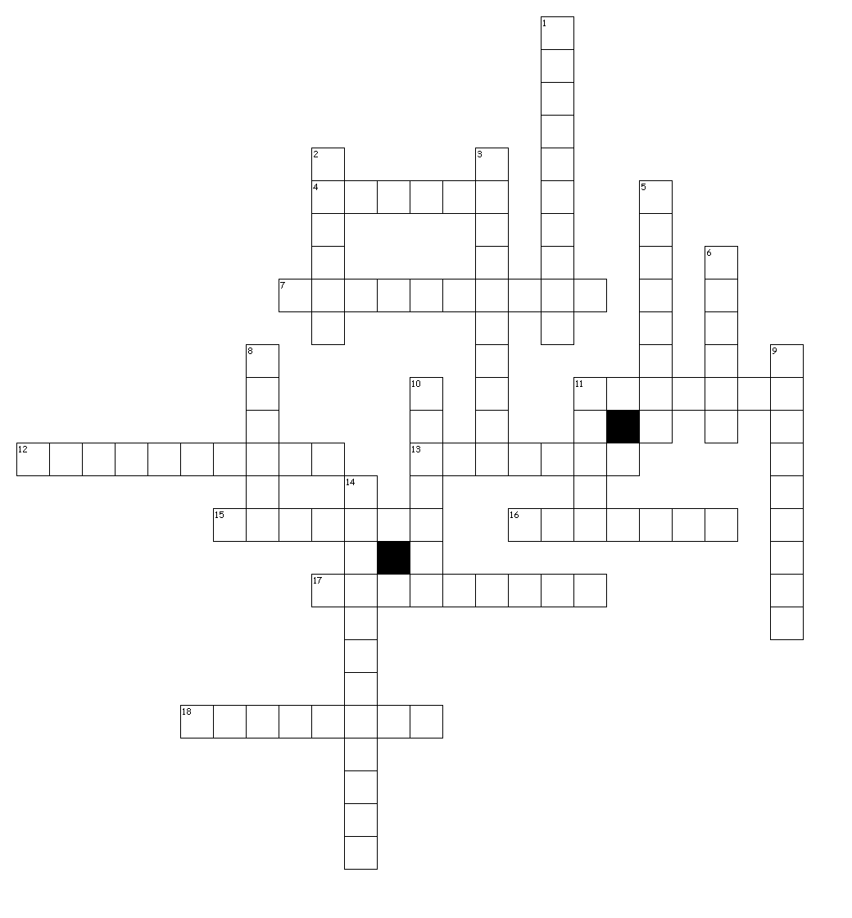

Across
4. large territory all under one ruler
7. worship of many gods
11. an area of high, flat land
12. method of watering crops
13. a craftsperson such as a potter or weaver
15. rich, good for growing
16. the ruling family of an empire
17. a city that is an individual unit with its own government and traditions
18. an agreement

Down
1. the worship of one god
2. an area with common physical features
3. a person who is born later into the same family
5. a large pyramid shaped structure used as a temple
6. the exchange of goods and services
8. a professional writer
9. wedge-shaped writing formed into wet clay
10. the practice of owning another person
11. an area of flat land
14. group of people in a complex, organized society

