Ancient China Review Puzzle
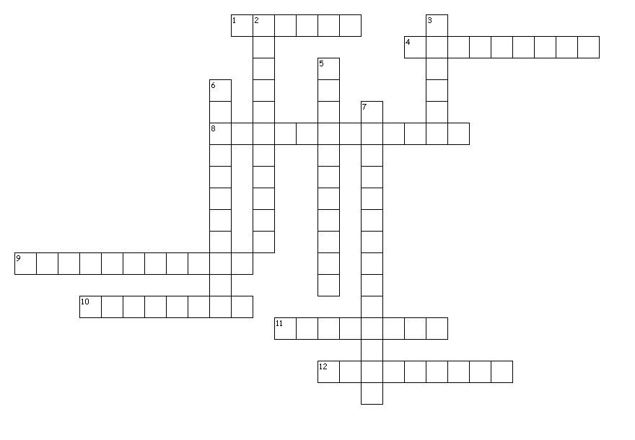
Across
1. Philosophy that focuses on the natural order of things
4. Period pf peace, prosperity, and advancement
8. Philosophy that focuses on morals, order, and respect
9. Device the measures the strength of earthquakes
10. Philosophy that believes in rule by fear
11. Trade route that connected Asia and Europe
12. Built to keep out invaders and nomads

Down
2. Method of relieving pain by inserting needles into pressure points
3. Having the ability to know right from wrong
5. used by the Shang to tell the future
6. Chinese style of writing
7. Geographic feature that separates China from other places

